Rouse Opticians
Information for Patients
Age-Related Macular Degeneration
CONTENT LIST  What is the macula?  How does AMD damage vision?  Who is at risk for AMD?  What are the symptoms of AMD?  How is AMD detected?  How is AMD treated?  How is laser surgery performed?  What research is being done?  What can you do to protect your vision? | This pamphlet is designed to help people with age-related macular degeneration and their families better understand the disease. It describes the causes, symptoms, diagnosis, and treatment of age-related macular degeneration.  Age-related macular degeneration (AMD) is a disease that affects your central vision. It is a common cause of vision loss among people over the age of 60. Because only the centre of your vision is usually affected, people rarely go blind from the disease. However, AMD can sometimes make it difficult to read, drive, or perform other daily activities that require fine, central vision.  What is the macula?  The macula is in the centre of the retina, the light-sensitive layer of tissue at the back of the eye. As you read, light is focused onto your macula where millions of cells change the light into nerve signals that tell the brain what you are seeing. This is called your central vision. With it, you are able to read, drive, and perform other activities that require fine, sharp, straight-ahead vision.  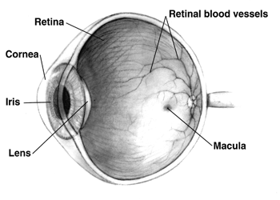  How does AMD damage vision?  AMD occurs in two forms:  Dry AMD affects about 90 percent of those with the disease. It is caused when the cells in the macula become damaged by a build up of debris called Drusen. Slowly, the light sensitive cells in the macula break down. With less of the macula working, you may start to lose central vision in the affected eye as the years go by. Dry AMD often occurs in just one eye at first but you may get the disease later in the other eye. Doctors have no way of knowing if or when both eyes may be affected.  Wet AMD--Although only 10 percent of all people with AMD have this type, it accounts for 90 percent of all severe vision loss from the disease. It occurs when new blood vessels behind the retina start to grow toward the macula. Because these new blood vessels tend to be very fragile, they will often leak blood and fluid under the macula. This causes rapid damage to the macula that can lead to the loss of central vision in a short period of time.
Who is at risk of AMD?
Although AMD can occur during middle age, the risk increases as a person gets older. Results of a large study show that people in their 50s have about a two percent chance of getting AMD. This risk rises to nearly 30 percent in those over age 75. Besides age, other AMD risk factors include:
Gender--Women may be at greater risk than men, according to some studies.
Smoking--Smoking may increase the risk of AMD.
Family History--People with a family history of AMD may be at higher risk of getting the disease.
Cholesterol--People with elevated levels of blood cholesterol may be at higher risk for wet AMD.
What are the symptoms of AMD?
Neither dry nor wet AMD causes any pain. The most common symptom of dry AMD is slightly blurred vision. You may need more light for reading and other tasks. Also, you may find it hard to recognise faces until you are very close to them.

As dry AMD gets worse, you may see a blurred spot in the centre of your vision. This spot occurs because a group of cells in the macula have stopped working properly. Over time, the blurred spot may get bigger and darker, taking more of your central vision.
People with dry AMD in one eye often do not notice any changes in their vision. With one eye seeing clearly, they can still drive, read, and see fine details. Some people may notice changes in their vision only if AMD affects both of their eyes.
An early symptom of wet AMD is that straight lines appear wavy. This happens because the newly formed blood vessels leak fluid under the macula. The fluid raises the macula from its normal place at the back of the eye and distorts your vision. Another sign that you may have wet AMD is rapid loss of your central vision. This is different from dry AMD in which loss of central vision occurs slowly. As in dry AMD, you may also notice a blind spot.

Normal vision.

The same scene as it might be
viewed by a person with AMD.
If you notice any of these changes in your vision, contact your eye care professional at once for an eye exam.
How is AMD detected?
Optometrists (opticians) detect AMD during an eye examination that includes:
Visual acuity test: This eye chart test measures how well you see at various distances.
Ophthalmoscopy: This examination enables your optometrist to see the retina and look for signs of AMD. To see more of the retina, ideally the pupils should be dilated and examined with an ophthalmoscope. To dilate your pupil drops are placed into the eye, which take approximately 25 minutes to work. After the examination, your vision may remain blurred for several hours. Often good images can be obtained with a fundus camera or scanning laser ophthalmoscope without dilation although sometimes it may still be necessary.
One of the most common early signs of AMD is the presence of drusen. Drusen are tiny yellow deposits in the retina. Your eye care professional can see them during an eye examination. The presence of drusen alone does not indicate a disease, but it might mean that the eye is at risk for developing more severe AMD.
While conducting the examination, your eye care professional may ask you to look at an Amsler chart. This grid is a pattern that resembles graph paper or a football coupon. You will be asked to cover one eye and stare at a black dot in the centre of the grid. While staring at the dot, you may notice that the straight lines in the pattern appear wavy to you. You may notice that some of the lines are missing. These may be signs of wet AMD (See the Amsler chart below.)
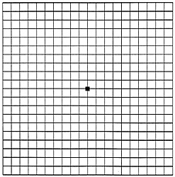 | 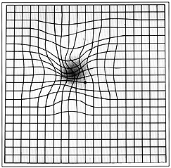
On the left is what an Amsler grid normally looks like, and the illustration on the right is how it might look to someone with AMD. These grids are reduced in size; you may well be given a full-size grid to use at home.
If your optometrist suspects you have wet AMD, you will be referred to the local eye hospital as you may need to have a test called fluorescein angiography. In this test, a special dye is injected into a vein in your arm. Pictures are then taken as the dye passes through the blood vessels in the retina. The photos help the eye doctors evaluate leaking blood vessels to determine whether they can be treated.
How is AMD treated?
Dry AMD currently cannot be treated. But this does not mean that you will lose your sight. Fortunately, dry AMD develops very slowly. You may lose some of your central vision over the years. However, most people are able to lead normal, active lives, especially if AMD affects only one eye.
Wet AMD can be treated with laser surgery but most are now treated by injection into the eye of drugs which prevent the growth of new blood vessels. This can prevent the further deterioration of the vision or even, in a minority of cases, improve the vision.
What research is being done?
Eye Institutes around the world are researching AMD. A number of research studies are being carried out both in the laboratory and with patients to learn more about the cause of AMD. This research should provide better ways to detect, treat, and prevent vision loss in people with the disease.
There is some suggestion that certain vitamins and minerals may play a role in the treatment of AMD. This treatment needs much more research before scientists can know for sure if it is helpful.
Scientists have begun to study the possibility of transplanting healthy cells into a diseased retina. Although this work is at a very early stage and still experimental, someday it may help people keep their vision or restore some lost vision.

